ZYX-S 4.0 Upgrade Instruction Manual
- Upgrade items
- Supporting dual satellite receiver or dual S-BUS receiver(using ZYX-S extended module)
- Supporting governor(using ZYX-S extended module)
- the stick response speed of the main rotor, add a burst coefficient of the main rotor, improve the performance of the hard flight
- Improve the stability of pirouette and hover flight
- Adjust the channel assignment of S-BUS receiver to the default sequence of Futaba(if you are using a S-BUS receiver, please adjust the “FUNCTION” in your transmitter as ZYX4.0 PC software shows in receiver page)
- ZYX-S extended module instruction
- Wiring


- Using Governor
Please prepare a brushless RPM sensor or a magnet RPM sensor
Notice: the brushless RPM sensor is susceptible to interference from the ESC, servos, motors, etc. The brushless RPM sensor installation should be as far away as possible from the ESC, servos, motors, etc.
Check the direction of throttle signal in monitor page of ZYX4.0 PC software.
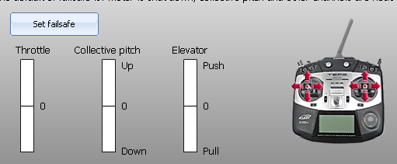
Click “Calibrate RPM” in “Advance Menu” page of ZYX4.0 PC software, click “Reset” to reset the parameters of governor.
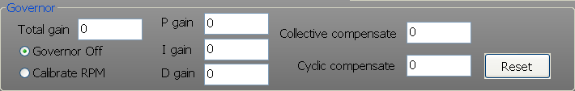
Exit the PC software, fly the helicopter at the highest RPM for one minute and landing, let ZYX-S to save the maximum RPM. If the RPM calibration is succeed, “Calibrate RPM” will change to “Governor on” in PC software. If Click “Governor Off”, change a motor, ESC, helicopter, etc, you need to calibrate RPM again.
Adjust the throttle curve in your transmitter. The helicopter will enter governor mode when the RPM is greater than 50% of the maximum RPM. The helicopter’s RPM is proportional to the throttle signal of transmitter, the helicopter run at maximum RPM when throttle signal is max. Throttle curve in Nomal and Idle mode is shown as an example below.
